**Five things you need to know about the conflict in Cabo Delgado:**

Mozambique’s northern province of Cabo Delgado is one of the poorest regions in the country. Since October 2017, the population of Cabo Delgado has suffered violent attacks by a non-state armed group. Over the past year, these attacks have grown in strength and brutality, as evidenced in the major attack on Palma at the end of March. While the reasons for this conflict are multifaceted, its consequences are strikingly clear: nearly 700,000 people have been displaced from their homes and are living with fear and insecurity, while struggling to access essentials such as food, water, shelter and medical care.

Here are five things you need to know about how the conflict is affecting people in northern Mozambique:

1. **Hundreds of thousands of people have been displaced**

In March 2020, an estimated 156,000[1] people had been displaced from their homes in Cabo Delgado province. A little over a year later, this figure has quadrupled, with nearly 700,000 people[2] forced to leave their homes due to the escalating violence. Entire villages have been burned to the ground, people have seen relatives killed in front of them, others have had their loved ones disappear, not knowing if they will ever come back. Thousands of people have escaped the violence by walking for days through the bush, in fear of being discovered and without food or water. Host communities and resettlement camps are overcrowded, and the displaced people are living in extremely poor and unsanitary conditions.

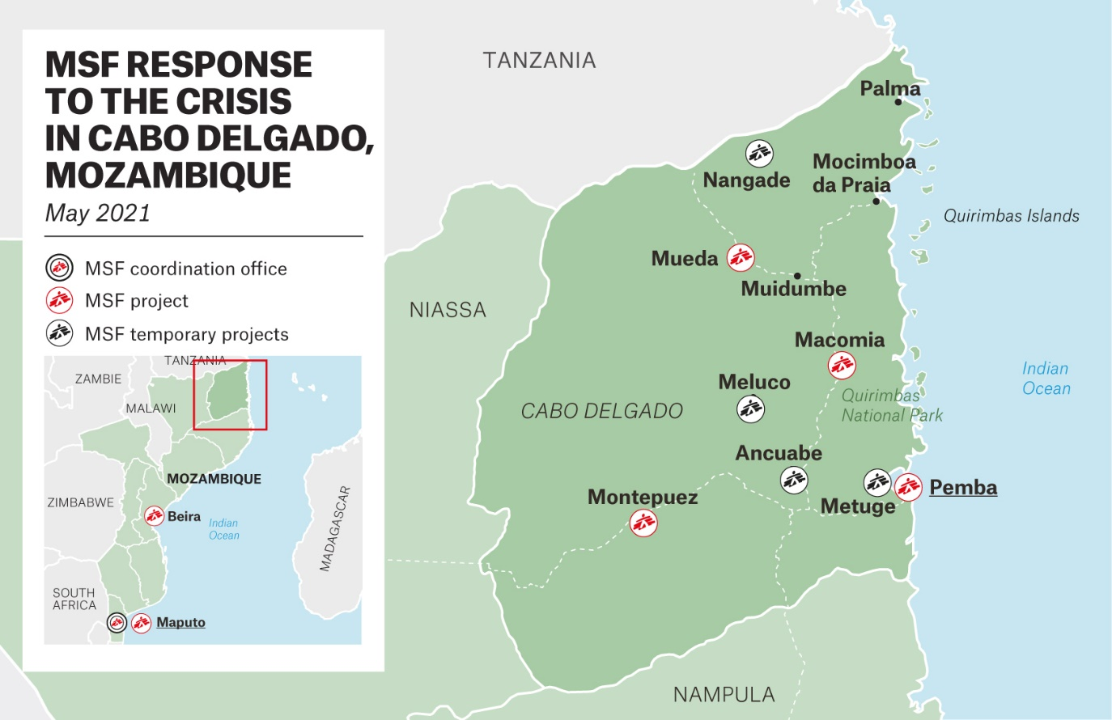

1. **People flee with nothing and need all the essentials**

People often flee their homes at short notice, with no time to gather provisions for the journey ahead. By the time they arrive in bigger towns like Pemba or Montepuez, after days of walking through the bush without food or clean water, they are often in a poor physical condition. Having fled with nothing, men, women, children, teenagers and the elderly need all the essentials: a place to sleep at night, a tent or materials to build their own hut, mosquito nets to protect them from malaria, clothes, blankets, food, water and medical care. People have left their entire lives behind, but their journey is only the first obstacle in their search for safety and stability, as the conflict in Cabo Delgado shows no sign of a resolution.

1. **Dealing with the psychological trauma caused by their experiences**

Having escaped the violence and survived a long and difficult journey to reach a resettlement camp or host community, people face another challenge: dealing with the psychological trauma. At the same time as struggling to find food, water, clothes and medical care, they are also trying to adjust to a new life. With every aspect of day-to-day existence a struggle, feelings of hopelessness and frustration are common. Many people suffer from post-traumatic stress disorder, have problems sleeping or experience nightmares. Some lose their appetite despite not having eaten for days. Being separated from loved ones and having no news of their whereabouts is also a major source of anxiety. Many people also live in constant fear of another attack. As Mozambique’s mental health programme is not very developed, providing mental healthcare is one of MSF’s priorities in Cabo Delgado.

1. **The region’s fragile health system has been hit hard**

More than one-third of health facilities[3] across Cabo Delgado province are reported to have been damaged or destroyed by the violence. In late 2020, there were no functional clinics in the hardest-hit districts of Mocimboa da Praia, Macomia, Muidumbe and Quissanga. Since the attacks in late March, Palma has joined this list. In some areas, insecurity prevents the government and aid organisations from providing healthcare, including vaccinations, sexual and reproductive healthcare, and drugs and treatment for HIV and tuberculosis, both of which have a high prevalence in Mozambique.

1. **People’s needs far outweigh the current humanitarian response**

As the number of people displaced by the conflict in Cabo Delgado continues to increase, the basic needs of the displaced people and the communities hosting them remain largely unmet. National efforts to provide a response are insufficient, and while UN agencies and some international organisations have teams in the province, they currently cover only a fraction of people’s needs. MSF has expanded its medical activities over recent months, running mobile clinics in several districts, implementing water and sanitation activities to ensure people have access to clean drinking water, and providing mental health support. The main diseases treated by MSF teams are malaria, diarrhoea and respiratory infections. MSF plans to continue working in Cabo Delgado province, providing medical care to as many people as possible, but its work is limited by administrative hurdles and restrictions. There is an urgent need to scale up the overall response to this crisis by bringing in additional humanitarian staff and supplies.

ENDS

1. <https://reliefweb.int/report/mozambique/mozambique-update-cabo-delgado-march-2020>
2. <https://erccportal.jrc.ec.europa.eu/Echo-Flash#/daily-flash-archive/4169>
3. <https://reports.unocha.org/en/country/mozambique/>